National University of Computer and Emerging Sciences

Operating System Lab - 06

## Lab Manual

Contents

Content **1**

Introduction to Kernel 2

Configuring New Kernel 2

Reference Link 6

# Introduction to Kernel

The kernel is a computer program that is the core of a computer's operating system, with complete control over everything in the system. On most systems, it is one of the first programs loaded on start-up (after the bootloader). It handles the rest of start-up as well as input/output requests from software, translating them into data-processing instructions for the central processing unit. It handles memory and peripherals like keyboards, monitors, printers, and speakers.

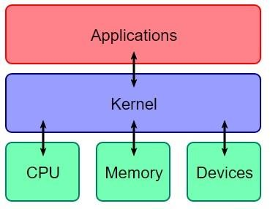

# Configuring New Kernel

1. Know what your previous kernel version is

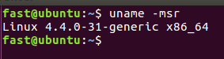

1. Update your system with $sudo apt update

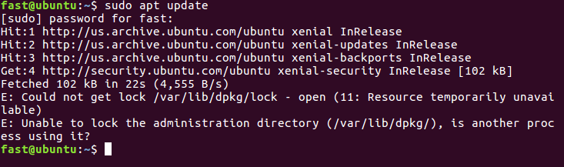

1. In case you are stuck with this error E: Could not get lock /var/lib/dpkg/lock. Grep that process which is holding your lock and kill that.

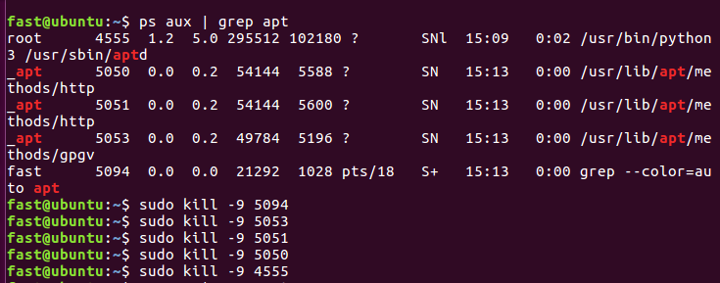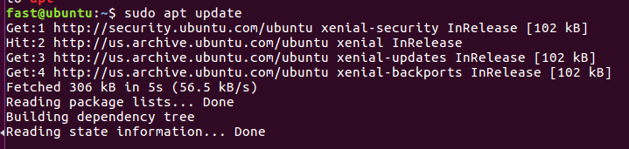

1. After your system has been successfully updated. Login with root to make kernel changes.

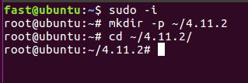

1. Now you have to download packages using wget

*wget https://kernel.ubuntu.com/~kernel-ppa/mainline/v4.1.30/linux-headers-4.1.30-040130_4.1.30-040130.201608091532_all.deb*

*wget https://kernel.ubuntu.com/~kernel-ppa/mainline/v4.1.30/linux-headers-4.1.30-040130-generic_4.1.30-040130.201608091532_amd64.deb*

*wget https://kernel.ubuntu.com/~kernel-ppa/mainline/v4.1.30/linux-image-4.1.30-040130-generic_4.1.30-040130.201608091532_amd64.deb*

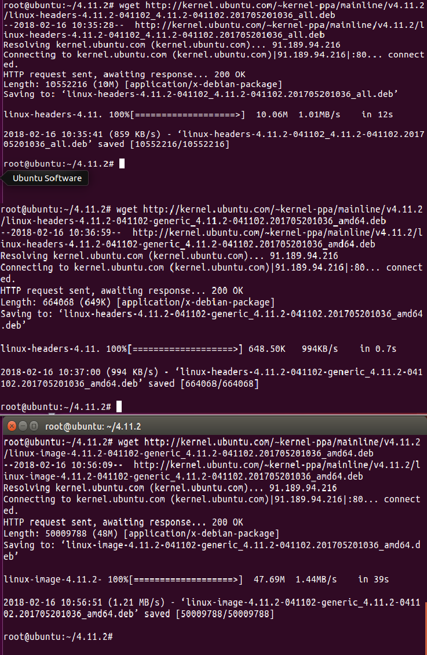

1. In case of successful download this will appear.

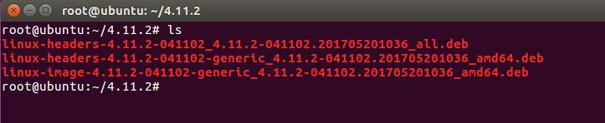

1. Now install the packages with the dpkg command below.

*dpkg -i *.deb*

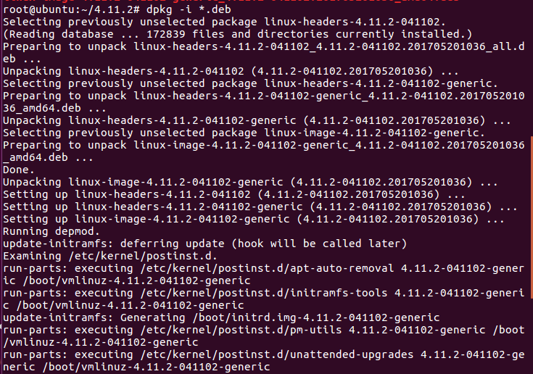

1. When the kernel package installation is complete, update grub and reboot the system.

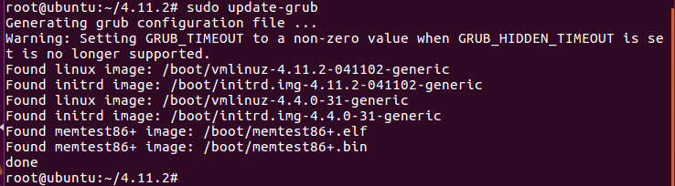

1. After server rebooting, check again the kernel version. Wooaahh Congo!!

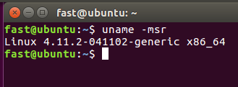

# Reference Link

https://[www.howtoforge.com/tutorial/how-to-upgrade-linux-kernel-in-ubuntu-1604-server/](http://www.howtoforge.com/tutorial/how-to-upgrade-linux-kernel-in-ubuntu-1604-server/)